Home task lab 2
K250899 Muhammad Anas
DLD
Miss Seema Hashwani

LAB TASK 1:
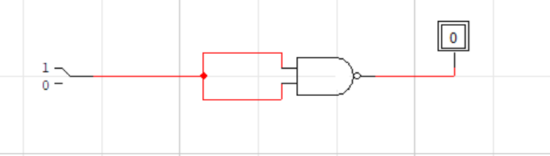

TRUTH TABLE:
Input (A) | Output (Y)
0 | 1
1 | 0

LAB TASK 2:
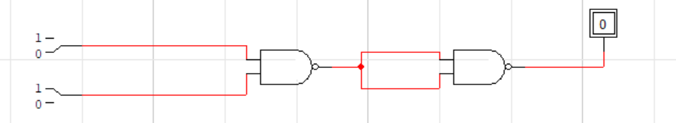

TRUTH TABLE:
Input (A) | Input (B) | (A⋅B)′ | Output (Y)
0 | 0 | 1 | 0
0 | 1 | 1 | 0
1 | 0 | 1 | 0
1 | 1 | 0 | 1

LAB TASK 3:

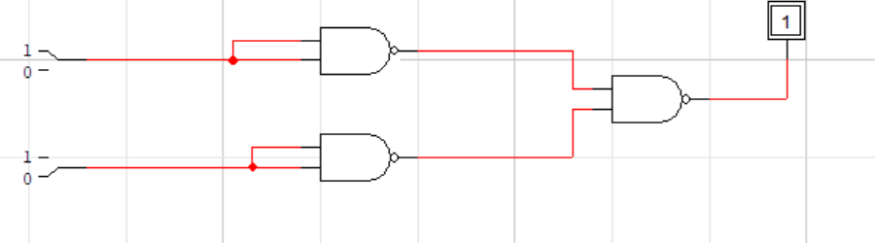

TRUTH TABLE:

Input (A) | Input (B) | A' | B' | Output (Y)
0 | 0 | 1 | 1 | 0
0 | 1 | 1 | 0 | 1
1 | 0 | 0 | 1 | 1
1 | 1 | 0 | 0 | 1

LAB TASK 4:

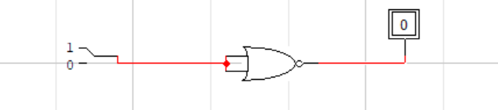 TRUTH TABLE:

Input (A) | Output (Y)
0 | 1
1 | 0

LAB TASK 5:

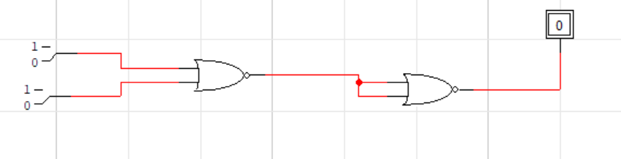

TRUTH TABLE:

Input (A) | Input (B) | (A+B)′ | Output (Y)
0 | 0 | 1 | 0
0 | 1 | 0 | 1
1 | 0 | 0 | 1
1 | 1 | 0 | 1

